This appendix sets out the benefits SkyDrive delivers and, addressing assessment feedback, makes explicit the line of sight from the project's component-level results to aircraft-level and fleet-level benefit, then quantifies the environmental, economic and strategic value to the UK. The figures used here are consistent with the rest of the application.
Table 1. Benefits at a glance, with the source of each in this appendix
Benefit | Headline outcome | Where it comes from
Aircraft-level | 30 to 80 versus 150 to 200 gCO₂ per passenger-km; extended range or payload | Efficiency above 97% and mass above 15 kW/kg (Section 7.1)
Environmental, fleet | Over 400,000 tCO₂ a year abated by 2040; about 900 t per 100 kW unit | 5% short-haul capture; per unit at 1,000 flight hours (7.2)
Economic | Around 1,220 UK jobs and £268m revenue by 2040; £37m reinvested | Lean model with ONS multiplier 1.72; export-led (7.3)
Strategic | Sovereign UK propulsion capability, at TRL6 by around 2029 | ATI Zero-Carbon priorities, ahead of the ~2030 point (7.5)
7.1. Line of Sight and Scalability, from Component Performance to Aircraft-Level Benefit: A central recommendation from assessment was to show how the targeted component improvements unlock the aircraft-level benefits stated in the application. The two levers are efficiency and mass (Figure 1). At over 97% system efficiency (motor at or above 96%, inverter at or above 98%), electrical losses through the powertrain are materially reduced, lowering the energy and, in hybrid configurations, the fuel required for a given mission. Against a representative incumbent integrated drive at around 95% system efficiency, which is about 5% loss, SkyDrive operating above 97% cuts loss to under 3%, a reduction in energy loss of the order of 40%, which is the figure stated in the application, with a correspondingly lower fuel burn in hybrid operation. At over 15 kW/kg active-material density and over 1.5 kW/kg at system level, the installation is substantially lighter than incumbent equivalents, and on weight-critical regional and sub-regional aircraft each kilogramme removed from the powertrain is returned to payload or battery energy, improving range and payload fraction. These map to concrete aircraft-level outcomes: approximately 900 tonnes of CO₂ saved per 100 kW unit each year, an intensity of 30 to 80 gCO₂ per passenger-kilometre against 150 to 200 for an equivalent turboprop, and extended range or payload on the short sectors that define early commercial viability. As an illustration, on a representative 100 kW, 100 kWh installation the combined efficiency and mass gains save around 47 kg against the current state of the art, which, redirected to battery capacity or payload, delivers 10 to 15% more range or useful load. The same fault-tolerant architecture is the basis for scaling to higher power: the power-electronics topology, the control and functional-safety framework and the thermal approach are reused across power levels, while the magnetic circuit, switch count and cooling are re-sized for each step (100 kW, then 250 to 500 kW, then MW-class), giving an engineered route to the higher-power regional and single-aisle hybrid propulsion that delivers the largest fleet benefit.
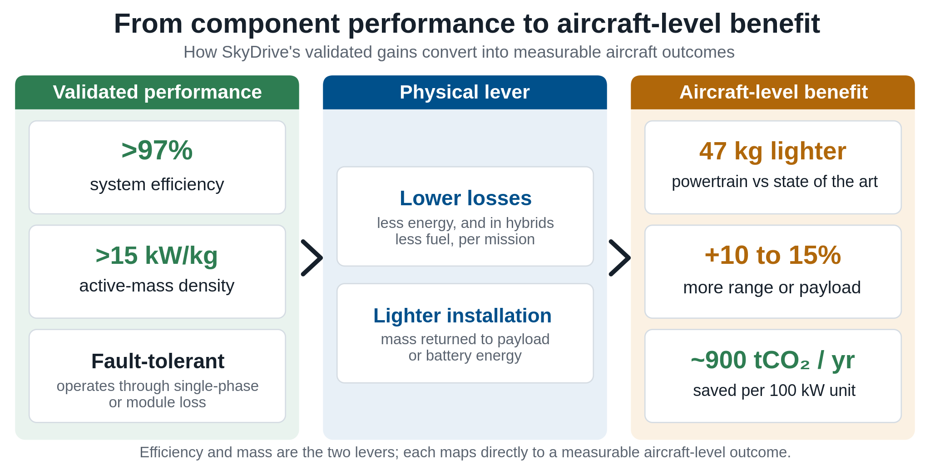
Figure 1. Line of sight from validated component performance, through the efficiency and mass levers, to aircraft-level and fleet benefit.
7.2. Environmental and Fleet-Level Benefits: Electrification of propulsion delivers a step change in aircraft emissions, and SkyDrive provides the powertrain that makes it certifiable (Figure 2). At unit level, a 100 kW SkyDrive replacing a turboshaft of comparable duty saves approximately 900 tonnes of CO₂ a year at 1,000 flight hours. At fleet level, capturing around 5% of the short-haul market would abate more than 400,000 tonnes of CO₂ a year by 2040. Per-mission intensity falls from roughly 150 to 200 gCO₂ per passenger-kilometre for a turboprop to 30 to 80 for an electric commuter, and lifecycle emissions shift from the ten-thousand-plus tonnes a fossil regional aircraft emits over its life, dominated by fuel, to a few hundred tonnes dominated by manufacture. Per flight hour, a small electric aircraft emits a few tens of kilogrammes of CO₂ against roughly 0.2 to 0.5 tonnes for a comparable turboprop. Electric operation also reduces airport noise by approximately 10 to 15 dB and eliminates NOx at the point of use. Social benefits follow: skilled regional jobs in the Midlands and South-East aerospace clusters, STEM engagement through UCL-led PhD and MSc training, and public confidence in greener aviation built through demonstrator flights. These outcomes align directly with the Jet Zero strategy and the UK's Net Zero 2050 commitment.
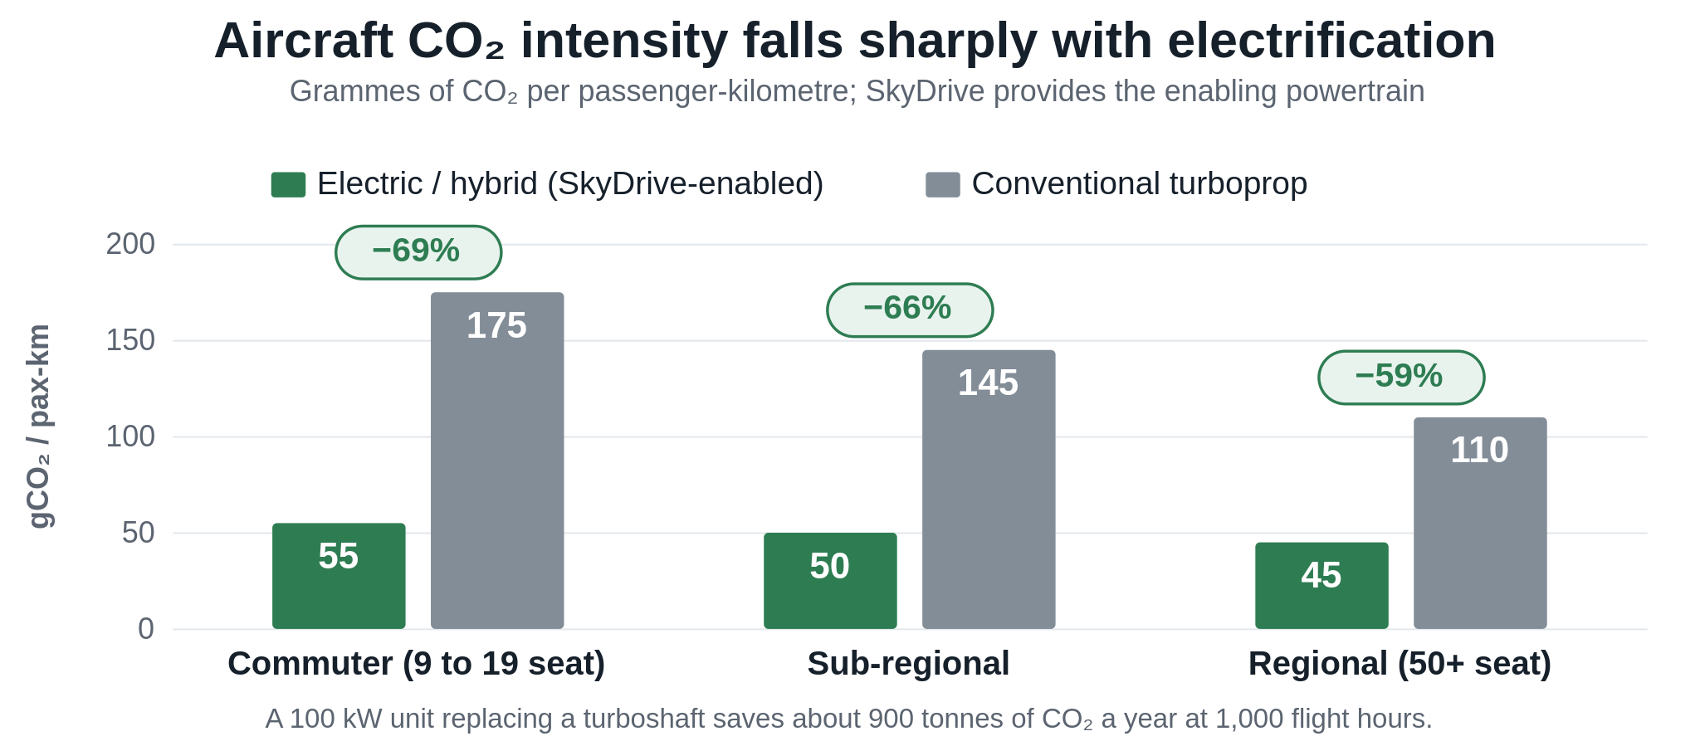
Figure 2. Aircraft CO₂ intensity, electric and hybrid versus conventional, across the classes SkyDrive's propulsion addresses.
7.3. Economic Benefits, Investment, Jobs and Revenue: SkyDrive is an R&D programme of approximately £1.9m over three years that de-risks the propulsion subsystem ahead of industrialisation, and no capital is sought in the ATI application. The project is part-funded by approximately £0.42m of industrial match funding, evidencing commercial commitment and risk-sharing. Post-project industrialisation and certification over 2029 to 2032 is estimated at £37m, front-loaded in capital equipment such as test rigs, automated motor winding, inverter assembly lines and aerospace-grade thermal facilities, with operating expenditure rising as production scales and a continuing tail of certification spend (Figure 3).
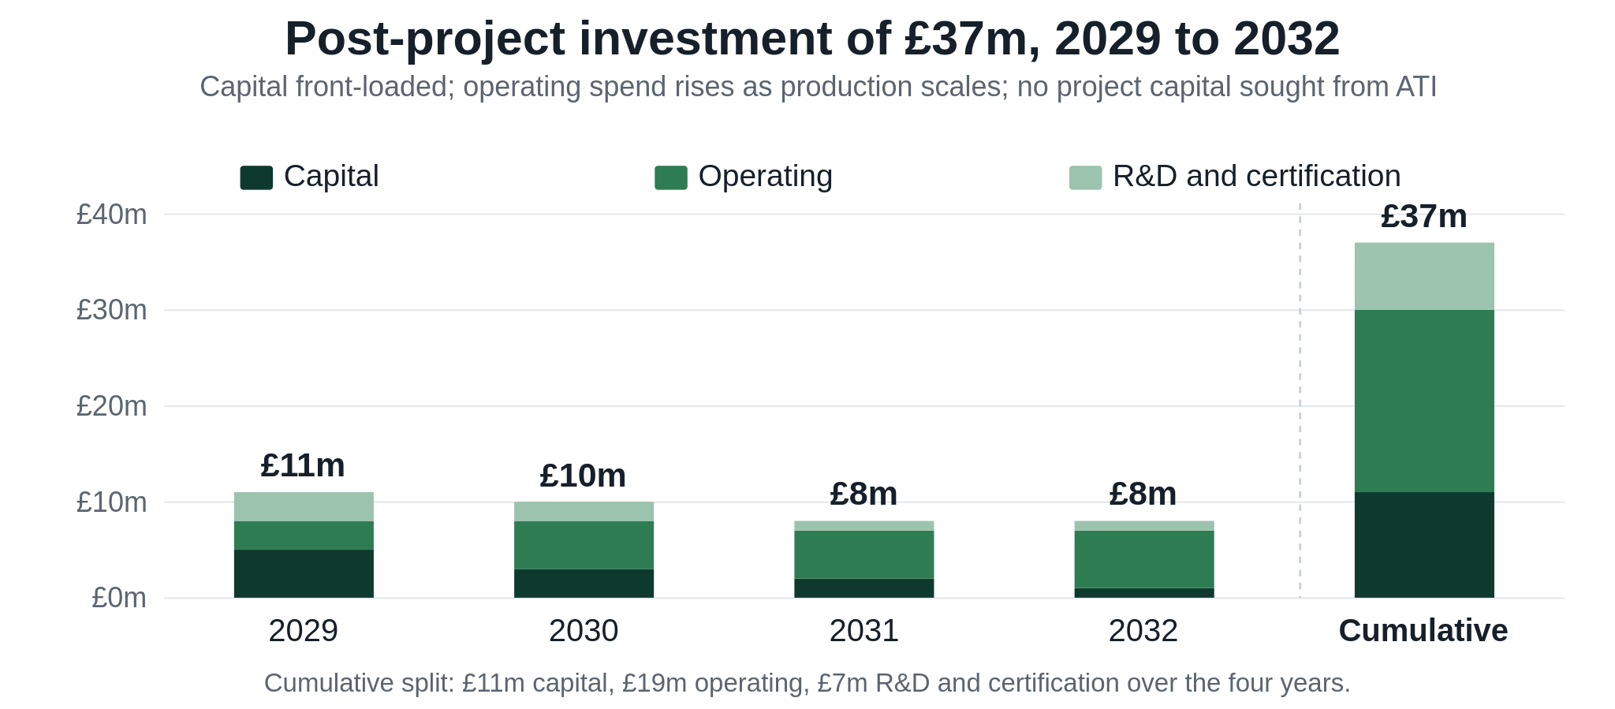
Figure 3. Post-project industrialisation and certification investment, 2029 to 2032 (£37m total), by category and year.
Employment is created across the consortium and its supply chain. The consortium operates a lean design-and-integration model, retaining design authority, final assembly, test and aftermarket while placing volume component manufacture with the UK supply chain, so the partners' own headcount stays modest while the supply chain carries the volume. On this basis direct UK employment is built bottom-up to approximately 450 by 2040 (iNetic around 280, ARC around 150, UCL around 20), and the ONS aerospace employment multiplier of 1.72 adds approximately 770 indirect roles, taking total UK employment to around 1,220 (Figure 4). The roles span power-electronics and systems engineering, test and validation, certification, manufacturing and aftermarket, concentrated in the Midlands and South-East aerospace clusters. Commercial revenue is forecast to grow to approximately £130m by 2036 and £268m by 2040, of which around £200m a year is export. Set against the ATI contribution of approximately £1.50m, the return is substantial: on the ATI's estimate every £1 of aerospace R&D leverages around £14 of whole-economy output.
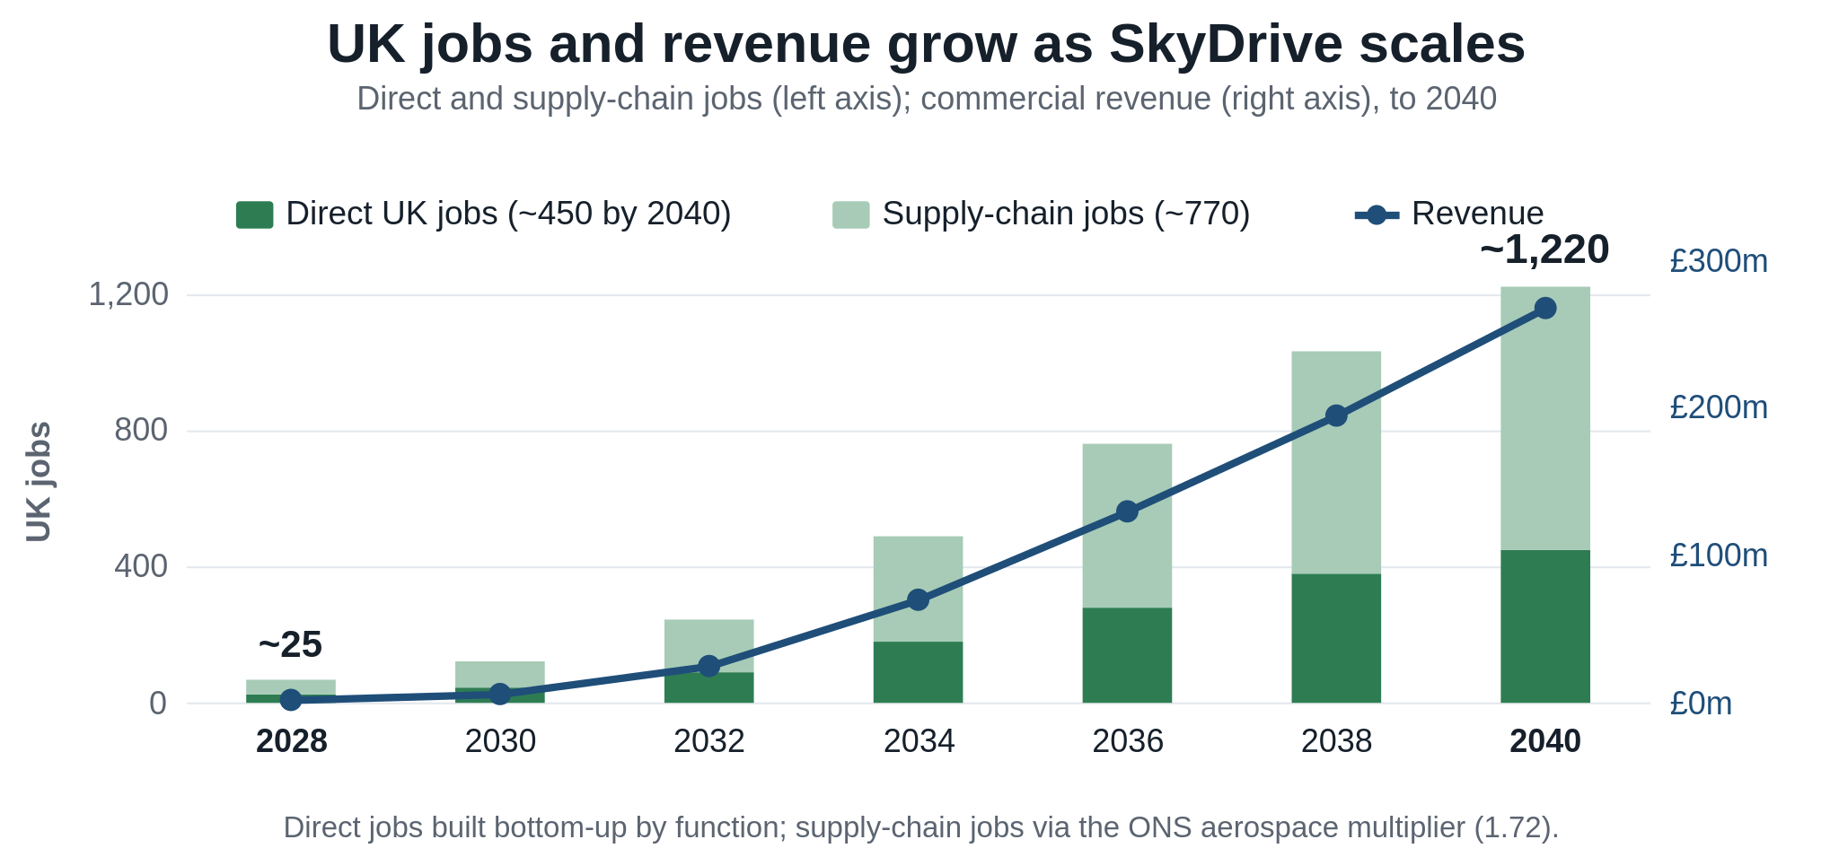
Figure 4. Projected UK employment and revenue growth to 2040, consistent with the bid's established figures.
7.4. Intellectual Property, Knowledge and Skills: Foreground IP is owned and managed by iNetic and protected through three patent families (multiphase inverter topology, integrated thermal management, and fault-tolerant control), with licensing options for original-equipment manufacturers seeking modular electric-propulsion blocks. Knowledge creation includes UCL-led peer-reviewed publications, contributions to SAE and IEC standards, and five PhD completions, while Eaton's participation in the SAE AE-7/AE-10 activity carries project learning into the standards that govern aerospace electrical power systems, giving SkyDrive influence over the compliance baselines its products must meet. The skills pipeline, five PhD completions, MSc project integration and technician training through ARC and UCL, builds the specialist workforce that electric-propulsion roles will require, while public-facing dissemination through demonstrator activity and aerospace events such as the Farnborough International Airshow and ATI conferences builds confidence in greener aviation.
7.5. Strategic and UK Benefits, and Alignment with the ATI 2026 Strategy: SkyDrive's benefits extend to national strategic capability. The project re-shores propulsion capability, reducing dependence on overseas supply, and builds sovereign capability in electrical machines, power systems and electric propulsion, all named ATI priorities. It matures Zero-Carbon roadmap technologies, including the lightweight electric propulsion unit, high-voltage power systems and rare-earth-free motor, reaching TRL6 ahead of the approximately 2030 readiness point for next-generation programmes. By anchoring this capability in the UK during early market formation, SkyDrive contributes to the strategy's ambition to double UK aerospace market share by 2035 and to the six-fold growth in UK propulsion value, to over US$17 billion a year, that it projects to 2050, while supporting the levelling-up agenda. The larger prize the strategy identifies is the next-generation single-aisle aircraft, close to 70 percent of the more than 65,000 deliveries expected to 2050, and it is precisely the higher-power hybrid propulsion that SkyDrive scales toward which positions the UK supply chain for that opportunity. The project also leaves durable national capability behind it: ARC's flight-representative Pegasus environment provides a UK facility for distributed-propulsion validation that other developers can draw on, and the commitment to UK subcontractors, with four key companies and a base of more than 40 domestic suppliers identified, re-shores high-value manufacturing rather than importing it.
7.6. Commercialisation and Market Roadmap: The benefits are realised along a staged trajectory from validation to market and on to higher power. Validation to TRL6 completes by around 2029; industrialisation and certification run from 2029 to 2032; market entry from 2031 addresses hybrid trainers, advanced air-mobility platforms and regional demonstrators; and higher-power derivatives, at 250 to 500 kW and subsequently MW-class, are developed from the mid-2030s for sub-regional and single-aisle hybrid platforms, with larger-platform integration anticipated toward 2040. Each step reuses the datasets, verification artefacts and design workflows generated at TRL6, reducing the cost and risk of adoption for downstream platforms and bringing the wider benefits forward.
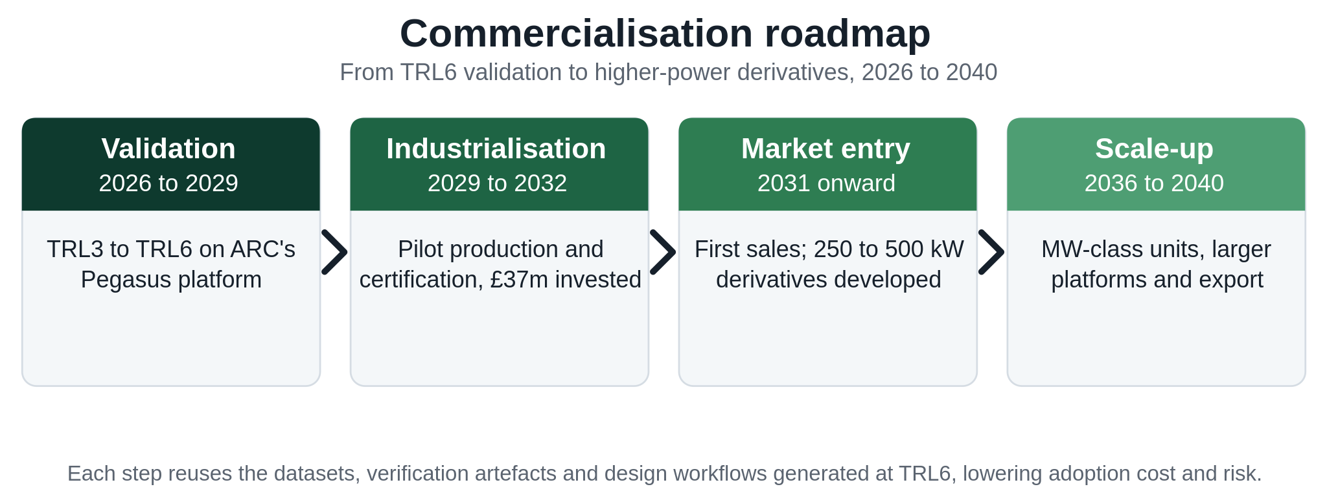
Figure 5. SkyDrive commercialisation roadmap, from TRL6 validation on the Pegasus platform to higher-power derivatives.
These environmental benefits are robust to assumptions about grid carbon intensity. The mass and efficiency gains reduce energy demand regardless of how that energy is generated, so the per-mission and lifecycle reductions hold on the current UK grid and improve further as it decarbonises toward 2050, while in hybrid configurations the same gains reduce fuel burn directly. The economic and strategic benefits are similarly resilient, resting on a lean, supply-chain-led delivery model and on sovereign capability that retains high-value activity in the UK rather than importing it.
Taken together, these benefits span the aircraft, the environment, the UK economy and national strategy: a TRL6-validated propulsion subsystem with a clear line of sight to aircraft-level benefit; substantial CO₂ abatement at unit and fleet level; around 1,220 UK jobs and export-led revenue; and a sovereign capability that places the UK supply chain in line for the next-generation hybrid-electric opportunity, in step with the ATI 2026 strategy and Net Zero 2050.

